**Deliverable #7: Final Documentation and Port Infiltration**

**Project: IoT Vulnerability Research Project**

**Participants:**

* Vikram Kher
* Varin Jaggi
* Tarik Wilkinson
* Patrick Kakooza
* Liza Moody
* Haoda Wang

**Introduction:**

For this deliverable, we compile the important information learned from the previous deliverables and include some final work completed on infiltrating the ports.

**New Information Learned:**

* We reviewed the manifest file for “intent.action” statements, however we were not able to find any useful information from this exploration.
* We attempted to send commands into the open TCP port. The result of this was that we found that the port spit out weird binary data
* Finally, we also found that the camera device seems to make hard-coded DNS lookups to tyua.com upon starting up
* Port 6668 emits binary data in response to commands from the app. Thus, we believe that the port most likely is an unopened debug port. However, the device was not responsive to SYN floods or any other link-layer attacks on that port. However, flooding in random data returns some form of binary data which may represent an “invalid input” output. Therefore this port seems to be a viable attack vector, and may provide valuable information on the operation of the device to an adversary. More work will be needed to reverse engineer this protocol.
* Lookups are done to static, hardcoded URLs at “a2.tuyaus.com.” A tainted DNS entry for this may be a viable attack vector if the adversary already has access to the network. However, the MQTT and QUIC protocols are used over HTTPS and thus, if the certificate is hard-coded into the camera, this attack vector may not be viable.
* The ONVIF service used is unsecured and allows any network user to connect to the camera feed. This is a glaring security mistake which should be fixed.

**Summary of Previous Deliverables:**

**Deliverable 1:**

**Introduction:**

This semester-long CSCI401 capstone project will consist of attempting to exploit security faults in a “LaView” device. As part of this project, the members will be actively involved in analyzing both the hardware and software components of the security camera. The ultimate goal of the project would be to learn how to maliciously alter the behavior of the camera. For example, one final goal might be to gain the ability to remotely reset its camera view or alter its image output.

**Estimated Timeline:**

**Deliverable 2 Due February 6, 2022**

For deliverable 2 we are going to focus on researching the “LaView” device we will be working with this semester.

1. **Hardware Teardown**
   1. During this phase we will be disassembling the device and examining the design of the device.
2. **Information Research**
   1. During this phase, we are going to identify ICs within the device’s PCB(s) on “DigiKey Electronics” and “Electronic Components Distributor.”

**Deliverable 3 Due February 20, 2022**

For deliverable 3, we will focus on analyzing the different hardware components found in the Laview security camera device. As part of this analysis will conduct a memory extraction procedure on the device.

1. **Hardware Analysis** 
   1. Using the information from the ICs listed, we will try to identify the functions of various ICs and the interconnect protocols used by them.
2. **Memory Extraction**
   1. If possible, we will attempt to extract the contents of the memory chip, which may provide a copy of the device’s firmware or running programs on the device.

**Deliverable 4 Due March 6, 2022**

1. **Firmware Analysis**
   1. The extracted memory may also provide a copy of the underlying firmware that the program uses, which we will try to reverse engineer the interconnect protocols.
2. **Header Inspection**
   1. The firmware may provide insight into how the device may be updated through header pins on the PCB. If possible, we will want to see if it is possible to flash new firmware onto this device or otherwise extract data from it.

**Deliverable 5 Due March 27, 2022**

1. **OS & File System Inspection**
   1. If we gain access to the storage, we will be able to extract a copy of the file system on the device, which may provide more insights into the device’s operation.
2. **Static Code Analysis**
   1. We will attempt to analyze the binaries used in the device through static analysis methods such as binary analysis and symbolic execution.

**Deliverable 6 Due April 10, 2022**

For deliverable 6, focus will be on analyzing network features on the security camera as well as analysis of the mobile app.

1. **Network Analysis & Protocol/Authentication Investigation**
   1. We will run the binary using knowledge gained in the previous week on a network testbed. This will let us analyze the network behaviour of the application
   2. Using traffic captured in the last week, we will attempt to reverse engineer the protocols used by the application when operating.
2. **Mobile App Analysis**
   1. We will use static analysis and network analysis methods on the app instead of the device.
3. **Data Flow Interpretation**
   1. Using the data captured from the last few weeks, we will attempt to summarize where and what data the device sends and receives.

**Deliverable 7 Due May 1, 2022**

1. **S/W Tools Development**
2. **Programming Analysis**
3. **Pre-existing PoC**
4. **Presentation**

**Deliverable 2:**

**Introduction:**

For this deliverable, we first completed a hardware breakdown on the Laview camera. The hardware breakdown revealed a motor, camera module, and pcb board, among other things. We have provided some photos of the parts in this document. We additionally discovered a dataset on the camera module (“AK3918 HD IP Camera”). This dataset (found here: https://gzhls.at/blob/ldb/0/b/4/1/700cafec77419c2d7705f376c974b8d0ff72.pdf) seems to provide a wealth of information about how the camera’s hardware operates, including its encryption type. In future sprints, we would like to do more research on all of the chips on the pcb board. We will be clarifying tomorrow (2/7) with our stakeholder about what type of research on the components should be conducted.

**Possible Attack Vectors:**

We tentatively hypothesize some possible attack vectors. It may be possible to gain control of the camera by changing the address which the bootstrap module points to. Then, when the processor of the camera is reset, a new set of instructions could be run. Another possible attack vector would be to somehow overtake how the timers work on the camera module. We might then be able to generate timer interrupts at will and thus effect the operation of the camera.

**Photo of the teardown progress:**

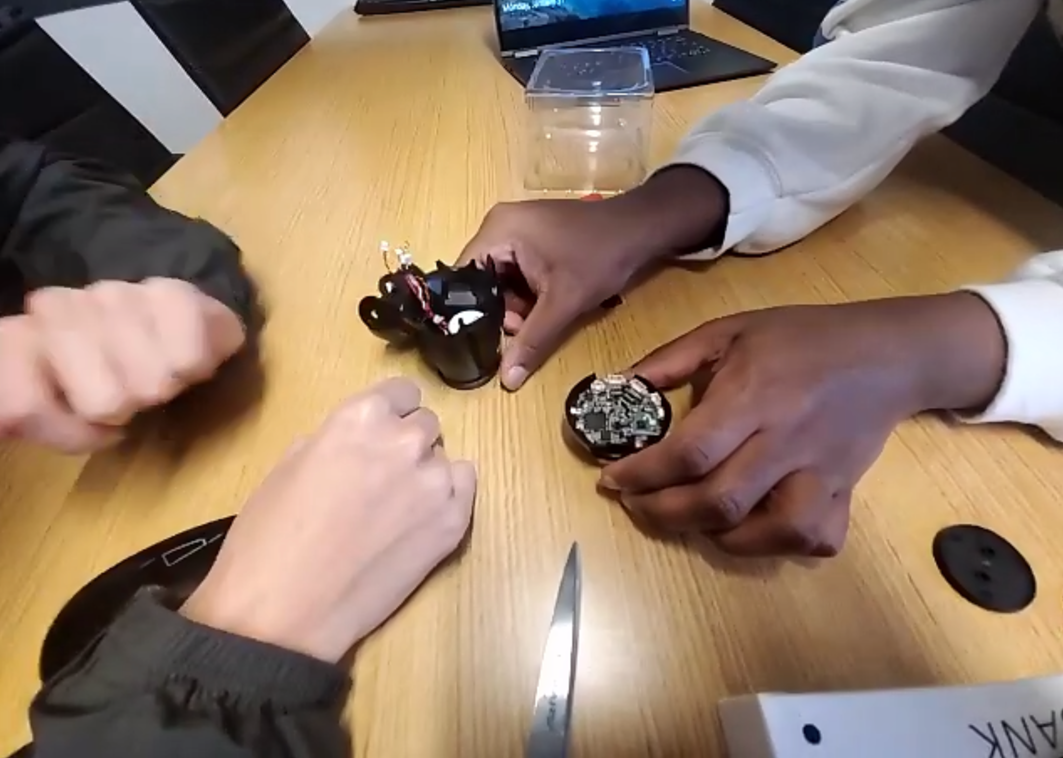

**Photo of Main PCB board:**

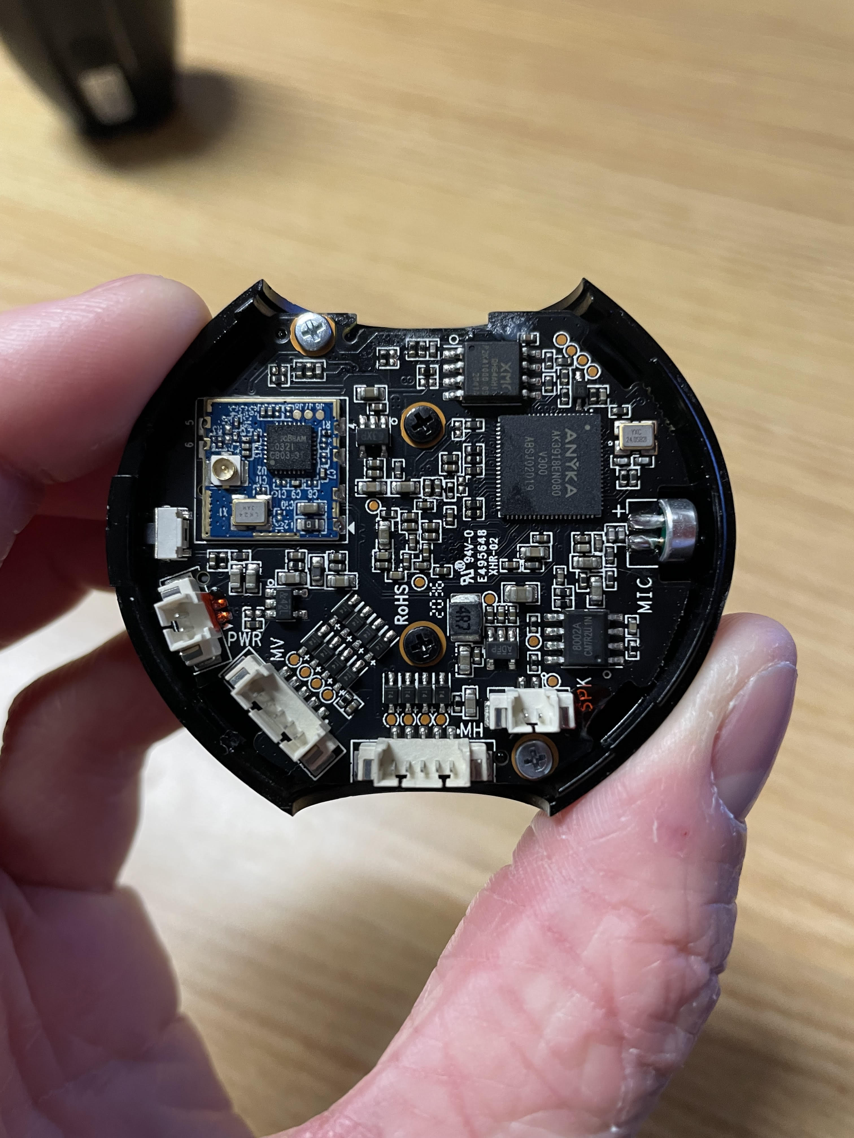

The following information was summarized or quoted from the specification document for the camera module (https://gzhls.at/blob/ldb/0/b/4/1/700cafec77419c2d7705f376c974b8d0ff72.pdf):

**Bootstrap Module:**

* When processor is reset, CPU cores get their first new instruction from address “32’0x0000,0000” from on chip ROM address space.

**RAM Controller:**

* 64mb DDR2
* Width of data bus is 16 bits

**Encryption:**

* “AES/DES/3DES Encryption module” encrypts video code stream.
* ”AES algorithm conforms with FIPS-197 standard.”
* “AES key length supports 128, 192, and 256 bits.”

**Features of Camera’s SoC:**

* **Anyka is the maker of the module**
* **(Information below is quoted from module spec)**
* ARM926EJ core, 16KB I cache and 16KB D cache
* advanced power management module
* supports little endian only
* Embedded 64MHz DDR2
* audio capability of MP3 encoder, ARM encoder, WAV encoder, Speex encoder
* MJPEG hardware encoder at 720p 30fps
* Multi-Stream encoding synchronously
* H.264 hardware encoder at 720p 30fps
* CCIR 601/CCIR 656 CMOS image sensor interface with programmable image size and
* smart scaling capability
* Ethernet MAC controller
* two ADCs for voice/music recording and battery measurement
* two Sigma-Delta DACs for stereo speakers
* built-in headphone driver
* I2S slave interface
* I2C master interface
* 2 UARTs, 1 has flow control
* rDA (under NEC protocol)
* ISP
* AES/DES/3DES Encrytion
* 2 SPI (master or slave operation)
* MMC/SD interface. MMC 4.2; SD 2.0
* SDIO interface, Version 1.1
* USB 2.0 HS Host/Slave
* 64 GPIOs, 7 dedicated, 57 shared with other pins
* JTAG supporting in-circuit debugging
* on-chip PLL and 32.768KHz RTC
* 5 PWMs
* 5 General Purpose timers
* 1 watchdog timer
* 1 RTC timer
* Four bootstrap modes, boot code saved in 32KB ROM
* package: 152-pin LFBGA”

**Timers:**

* 5 timers
* 26 bit down counter
* When timer reaches 0, the timer generates an interrupt

**CPU core:**

* Microprocessor called ARM926EJ from ARM Limited
* 32-bit ARM and 16 bit Thumb instruction sets
* Harvard cached architecture
* Contains memory management unit
* ”Separate instruction and data AMBA AHB bus interfaces”

**Deliverable 3:**

**Introduction:**

For deliverable 3, we continued working on the hardware analysis and began looking into the firmware of the La View camera to understand how data is transmitted to and from the device. In this phase, we identified the protocols used for the hardware and software components of the device. We pulled information from the datasheets we found in the last phase, which not only discussed the hardware side of the camera, but also provided information on how the camera operated on the software side. The camera uses *UART* protocol which is used for communication, *I2C* protocol which asks/requests information, and an ethernet module for communication with the SoC. The *I2S* interface is also used in the communication and processing of the digital audio in the camera, which can be leveraged to gain access to all digital audio from the camera. This phase of the project was heavily focused on understanding how the LaView camera works from a software standpoint and communicating with Professor Allen to gain access to a lab on campus.

Once we get access to the lab, we will work on utilizing the lab's equipment to test which of the copper pads on the device are active and how SOC is communicating with other components of the camera. We will also use the lab equipment to attempt to uncover what different commands the CPU is sending to other components of the device. Hopefully, these efforts will help us better understand the vulnerabilities of the LaView camera system.

**UART Protocol:**

UART is an acronym for Universal Asynchronous Receiver / Transmitter. The UART is a physical hardware device that serializes data from other components, such as the CPU, for communication purposes. The data is sent asynchronously between two UART devices which means that information does not flow according to a clock cycle. Instead of using a clock cycle, UART devices send “start” and “stop” bits with data to denote their boundary. In addition, UART also sends a parity bit, which can be used to tell if data has been corrupted during its transmission.

UART is a relatively simple hardware device. It contains only one input line (Rx pin) and one output line (Tx pin). Once we get access to a lab, we would like to use a scope device to be able to attempt to read the data sent between the two UART devices. This can be accomplished by looking at the voltages between sent between the two devices and comparing that to the ASCII table. Hopefully, by understanding the commands that are being send between the two devices, we will be able to insert our own commands into the system to control different devices.

**SPI Protocol:**

SPI is an acronym for Serial Peripheral Interface. The biggest benefit of the SPI protocol is that data can be sent in a continuous stream. This is in contrast to UART which sends data in blocks (separated by start and stop bits). SPI also utilizes a clock signal to synchronize data sent across its platform. SPI usually consists of a leader device and a follower device. The leader device, like a CPU, is responsible for controlling the follower device, like a sensor. The leader communicates via the MOSI line, while the follower receives its orders from the MOSI pin.

**I2C Protocol:**

I2C is an acronym short for Inter-Integrated Circuit. Two wires protocol: SDA (Serial Data) and SCL (serial clock). I2C combines the best features of UART and SPI. Is a serialization protocol done on a single SDA line, sending the data synchronously. Generally used for asking and requesting information. Has at least ONE master (leader) that can connect to one or MULTIPLE slave (follower) devices. The leader can send and request to followers. The clock signal is controlled by the leader. Generally less power than other communication protocols. All information is sent through messages using addresses to tell follower data is being sent to it. This message consists consist of:

* Start condition: SDA line switches from high to low voltage BEFORE SCL line switch
* Stop condition: SDA switch low to high voltage AFTER SCL line switch
* Address Frame: 7 to 10 bit sequence unique to each follower identifies which follower leader is speaking to
* Read/Write bit: single bit specifying whether leader is sending data to follower or requesting it
* ACK/NCK bit: if the address frame was successfully received, an ACK returned to the sender.
* Data Frame: the actual information being sent between devices

Each data frame is limited to 8 bits.

If multiple leaders are connected to the same bus, the leader must read SDA and ONLY send if high. (No leader is using it, free).

**NOTE**: can have a rather slow transfer rate than SPI, making it easier to intercept and interpret the data being sent.

**I2S Interface:**

This is the interface used to handle all the audio for the camera. The inter-IC sound (I2S) bus is a serial link developed especially for digital audio. The bus handles only audio data through a simple, 3-line serial bus consisting of:

* Continuous Serial Clock (SCK)
* Word Select (WS)
* Serial Data (SD)

I2S is a 3-wire protocol and we can use it in our project to retrieve audio data from the camera and potentially livestream the audio from the microphone of the camera. The interface protocol is used for the transmission of 2 channel (stereo) Pulse Code Modulation digital data, where each audio sample is sent MSB first. The working modes on our camera for I2S are:

* I2S transmitter slave mode:
* In this mode, the AK3918 accepts the BCLK and LRCLK signals and outputs the data from DAC controller to the external DAC via the I2S interface. The word length ranges from 4 bits to 24 bits, which is configured by DAC controller. If the word length of external DAC is more than 24 bits, 0s are added to the end of LSB.
* I2S receiver slave mode:
  + In this mode, the AK3918 accepts the BCLK signal, LRCLK signal and the data from external ADC via the I2S interface. The word length ranges from 3 bits to 16 bits, which is configured by ADC controller. If the word length of the external ADC is more than 16 bits, the LSBs are ignored.

**Ethernet Module:**

The ATBM603X module communicates with the SoC with a USB2.0 host interface. It utilizes 802.11i security and its operation frequency is 2.412 to 2.462GHz. The 802.11i security protocol is robust and utilizes a 4-way handshake and group key handshake protocol. These protocols help establish the authenticity of cryptographic keys.

**Linux drivers for SOC:**

While searching for the SDK, we found a fork of Linux v. 3.4.35, which included the drivers for the SoC and the camera parts. This was found as part of a different open-source camera project, however from the documentation within the code it seems like it originates from the SoC vendor. As this version of Linux was released in Mar 2013, and at least ~1000 CVEs listed for the kernel since then, the camera is most likely vulnerable to at least one of these exploits.

The vendor wrote custom non-in-tree drivers for the camera and CPU architecture, which are potentially vulnerable since they have not passed the checks typically done before a merge into the mainline Linux kernel. As there are no merge requests to the mainline kernel for these drivers, we also cannot speculate as to what vulnerabilities these drivers might hold. Future work may involve using static analysis techniques to search for vulnerabilities within this kernel that may be exploited.

**Deliverable 4:**

**Introduction:**

For deliverable 4, one of our primary goals was to thoroughly examine which connections on the PCB board were active. To accomplish this, we went to the OHE240 lab at USC where we had access to a multimeter and an oscilloscope. Through the use of the oscilloscope in particular, we were able to determine several active connections, which we stated further down in the document. Another one of the primary goals of this deliverable was to configure our raspberry pi to act as a UART transmitter and receiver device. We encountered some difficulties with getting the raspberry pi running, which we will tackle in the next deliverable. We would like to configure the raspberry pi device so that it can input commands to the LaView camera.

**Lab Setup :**

(Pictures with active pins and serial data in the end)

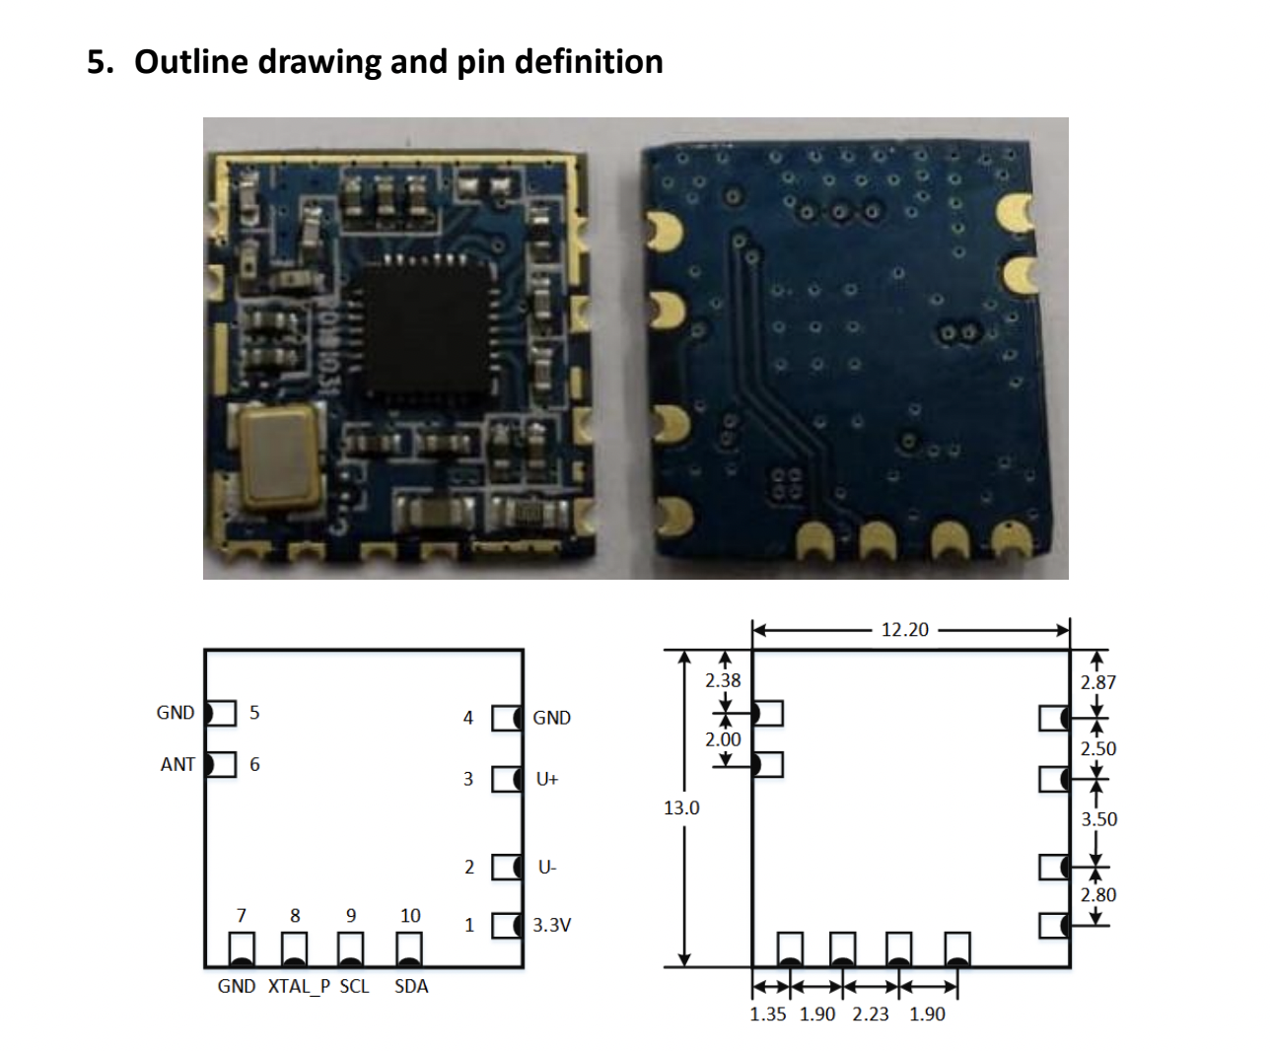

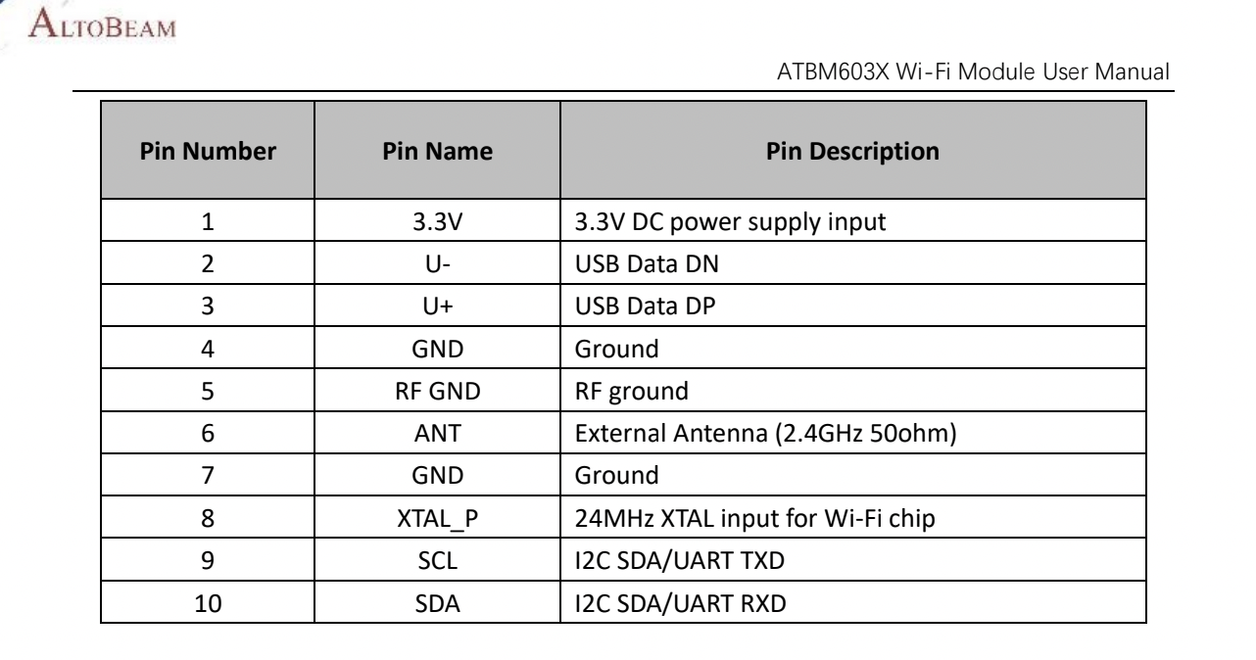

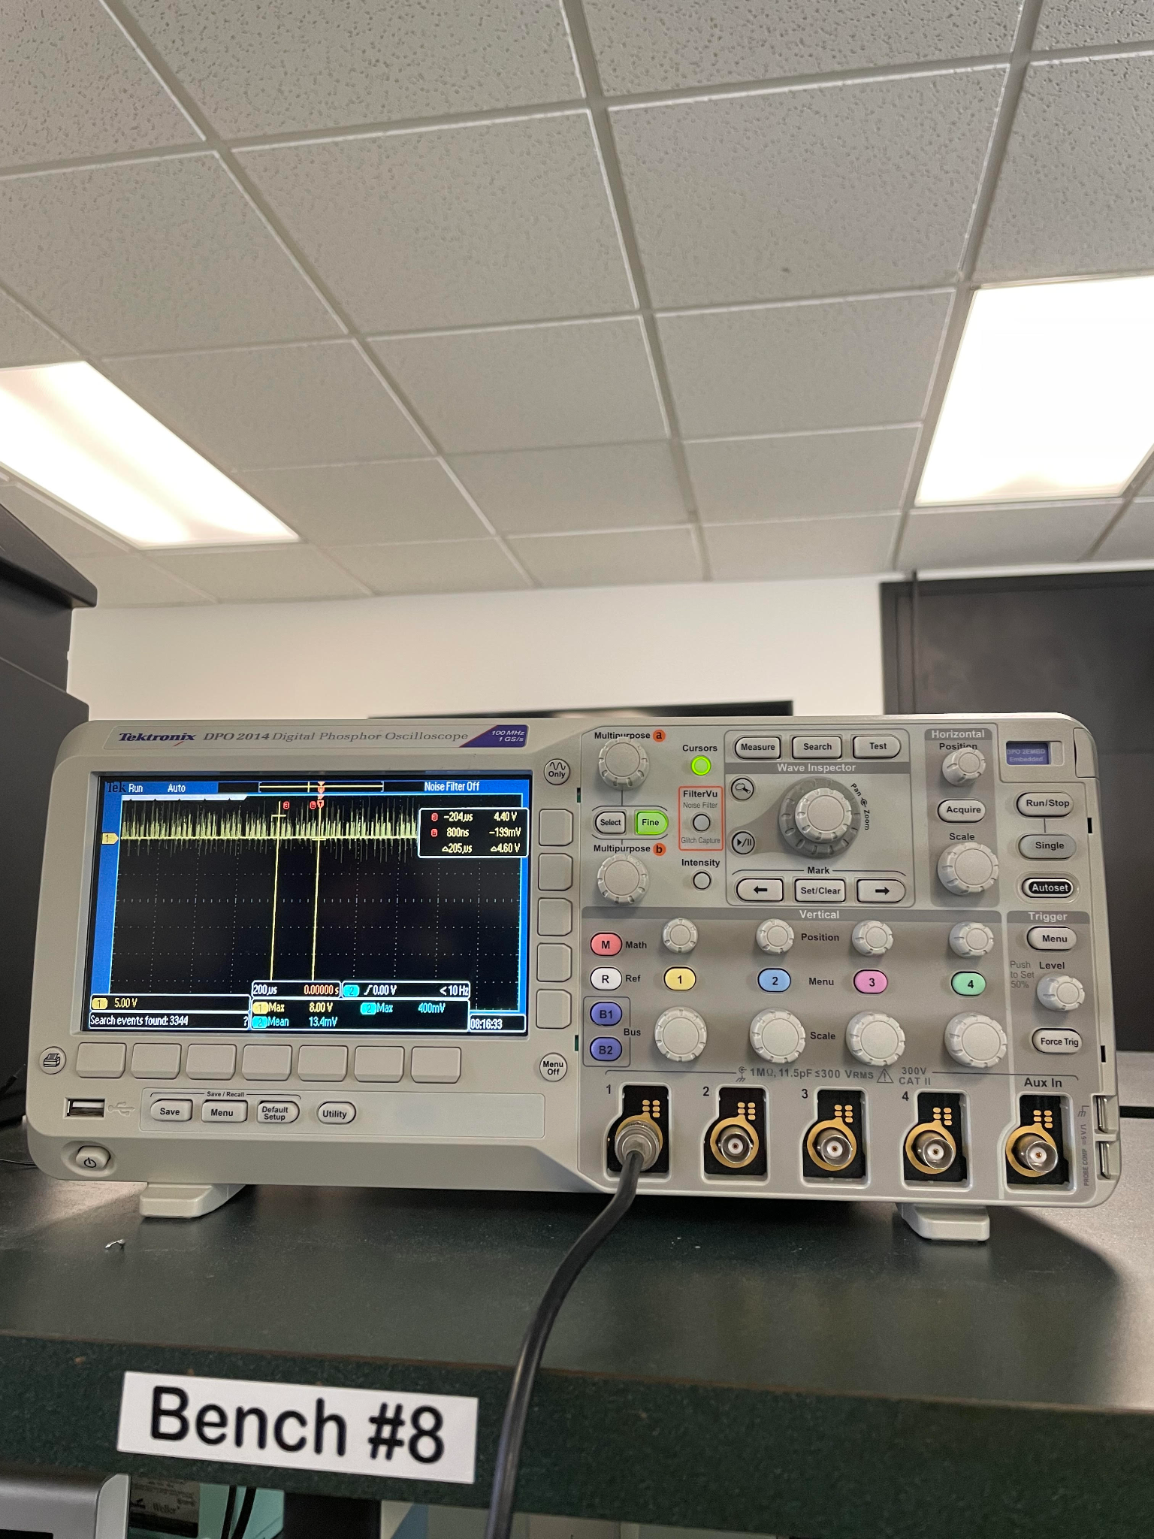

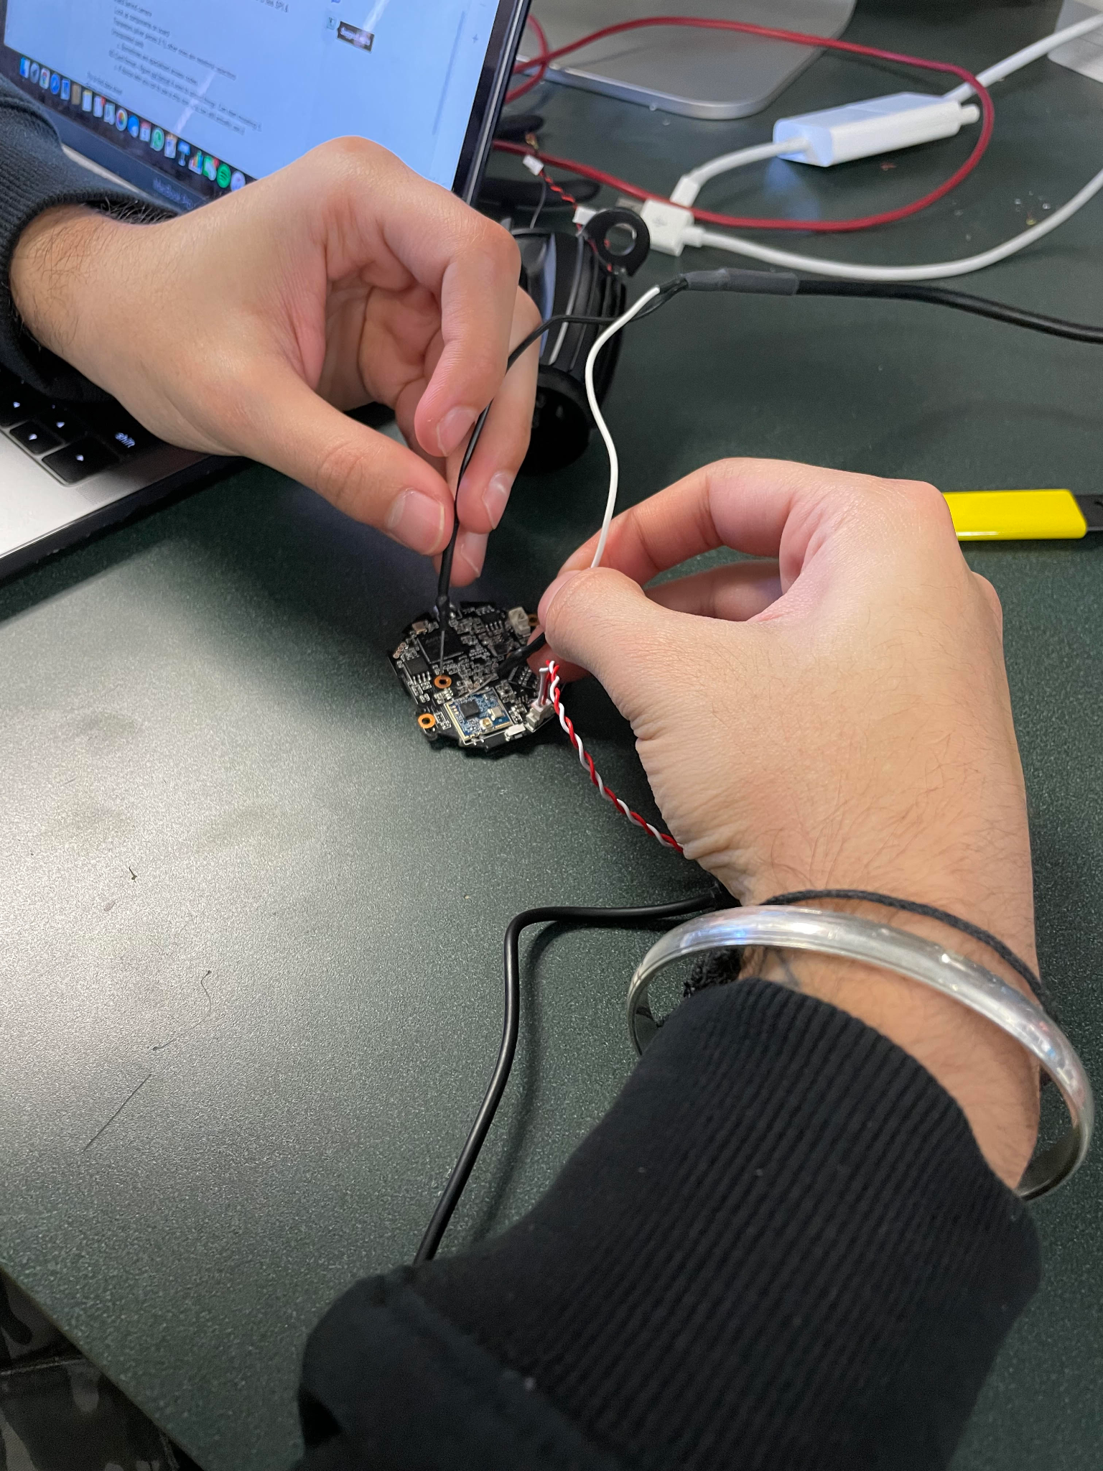

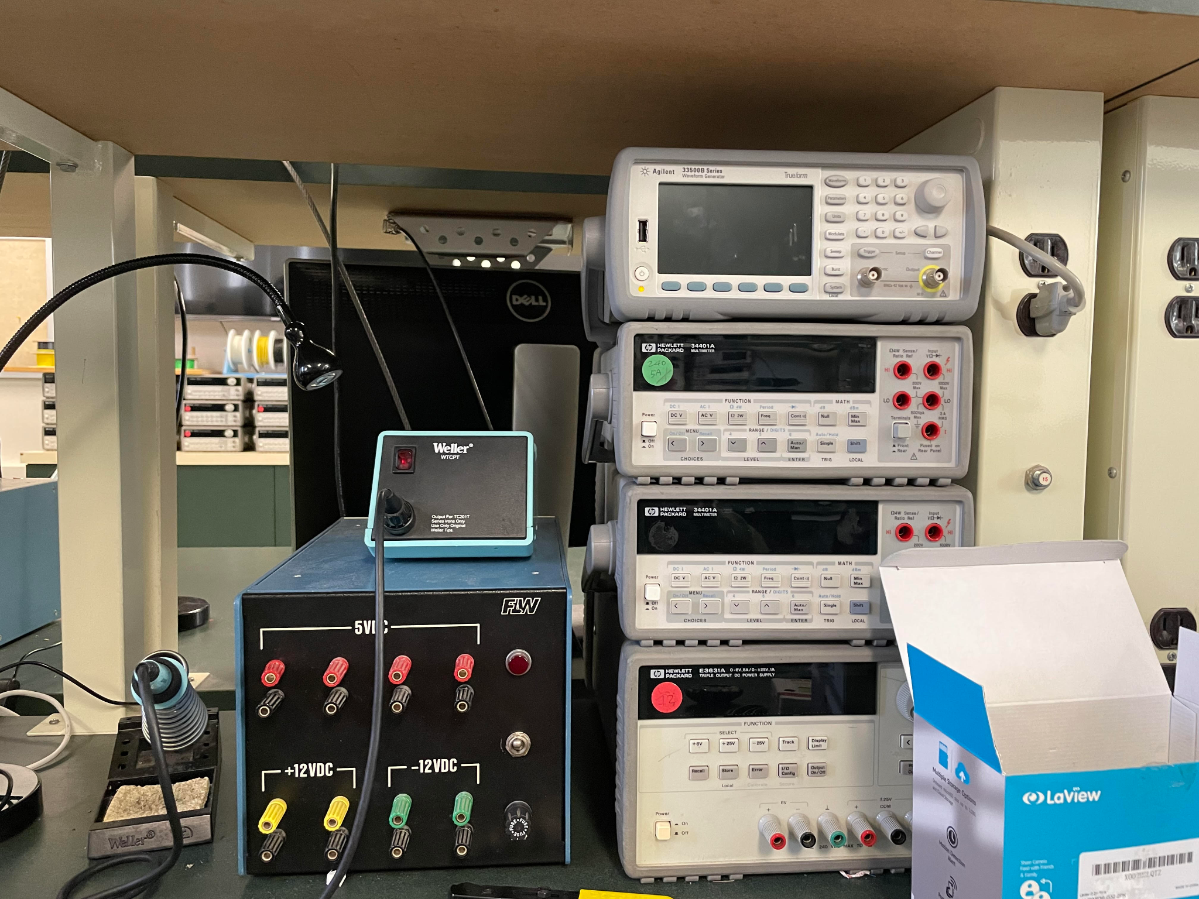

**Front of Chip (4 active pins found - circled in red):**

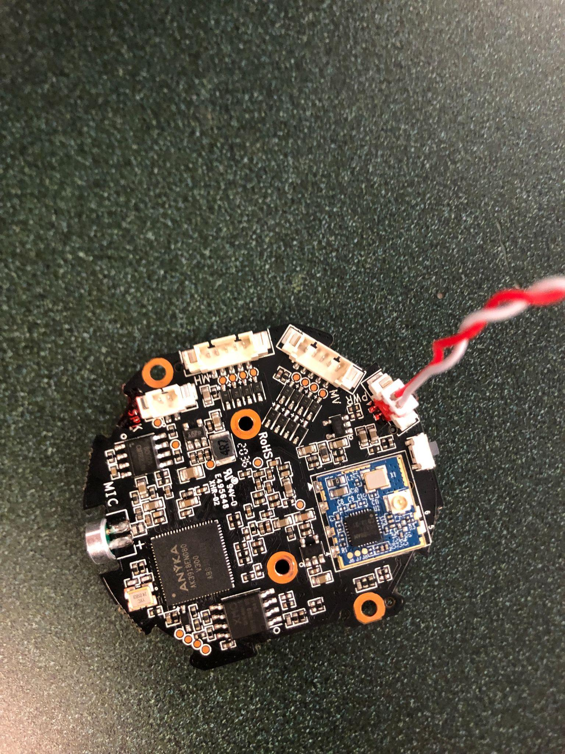

**Back of Chip (6 active pins found - circled in red):**

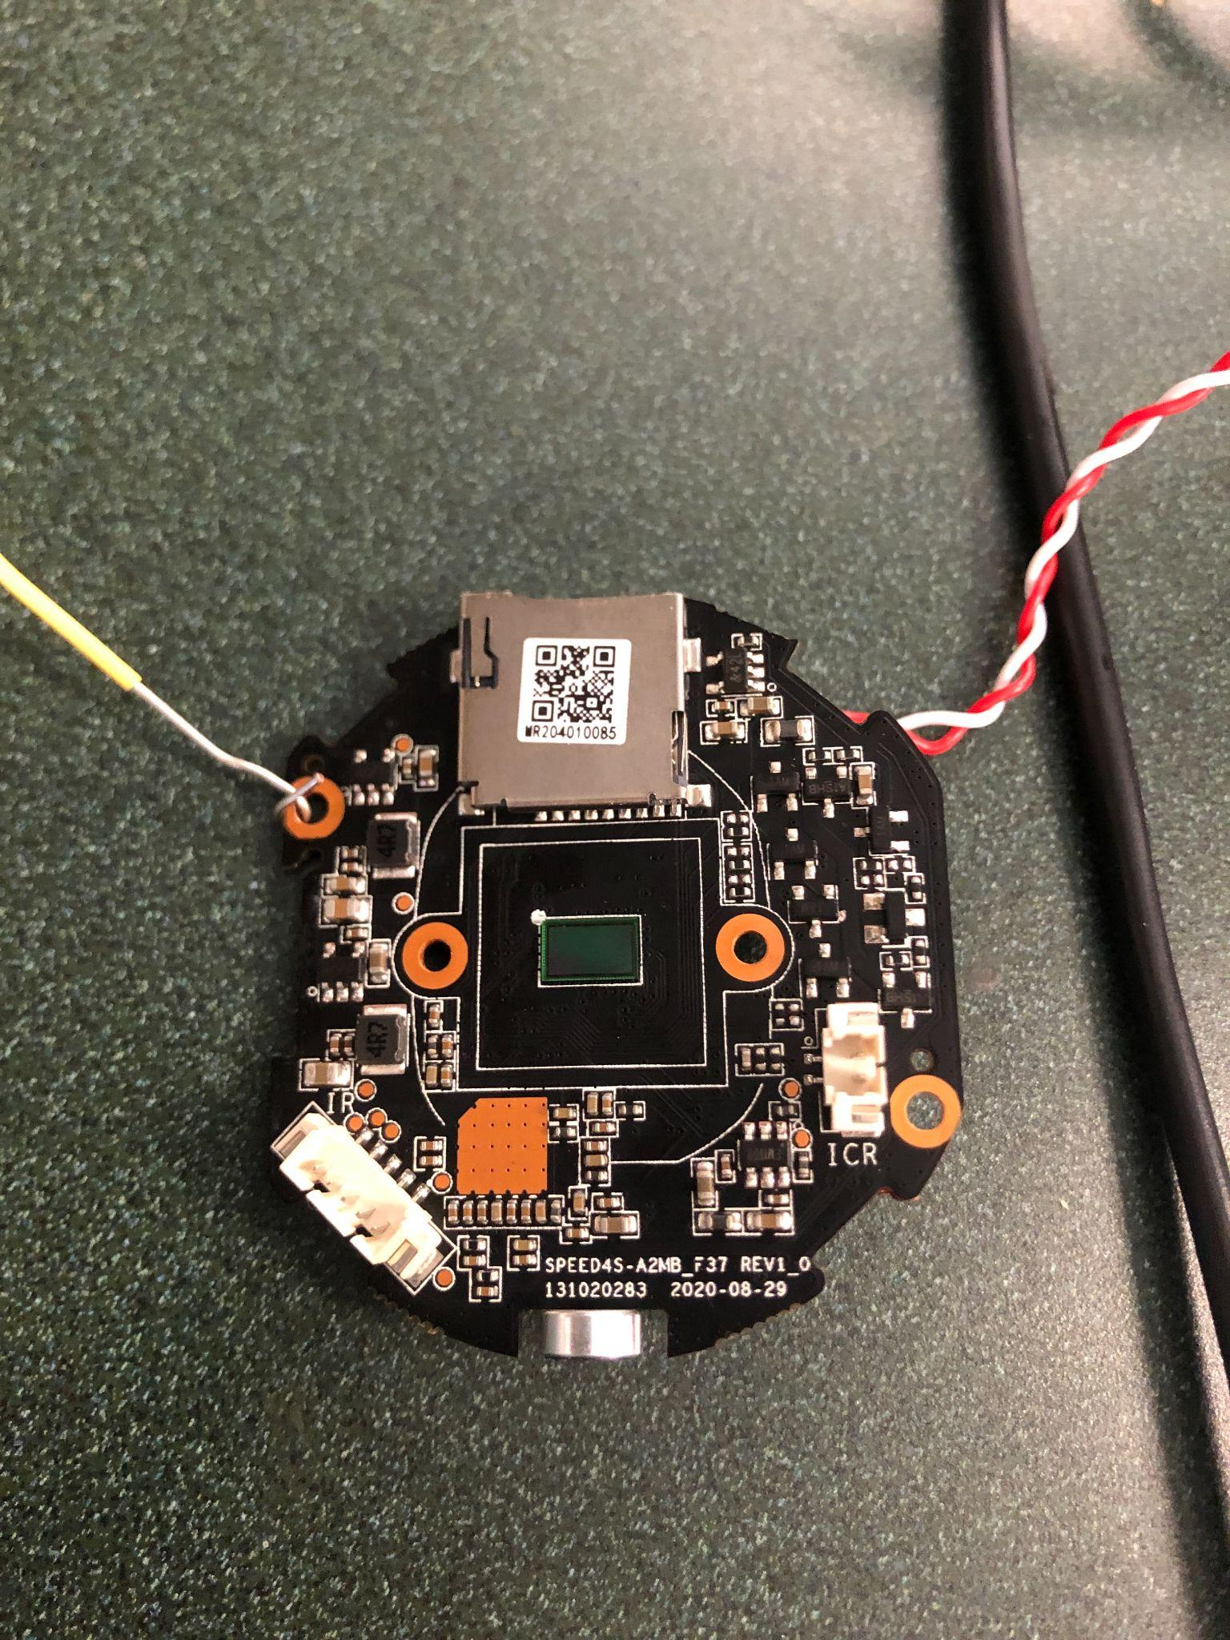

**Pins found transmitting serial data (circled in yellow):**



Yellow is receive

Orange is transmit

Black is ground

Red is 5 voltsr

**Deliverable 5:**

**Introduction:**

For this deliverable, we switched our focus from hardware analysis to software analysis. Our primary tool that we used for this deliverable is the open source software Ghidra (https://github.com/NationalSecurityAgency/ghidra). Ghidra allows us to reconstruct the source code of several files from an apk. We managed to locate an apk file corresponding to our La-View camera and ran it through Ghidra. We present some of our findings below. Besides using Ghidra, we had wanted to use wireshark to analyze the network packets from the La-View Camera. Unfortunately, we do not currently have access to the La-View camera hardware due to activities surrounding a previous deliverable. We will work on the wireshark analysis for next deliverable.

**APK Extraction**

APK has same compression format as a .zip file, so just extract. Result layout:

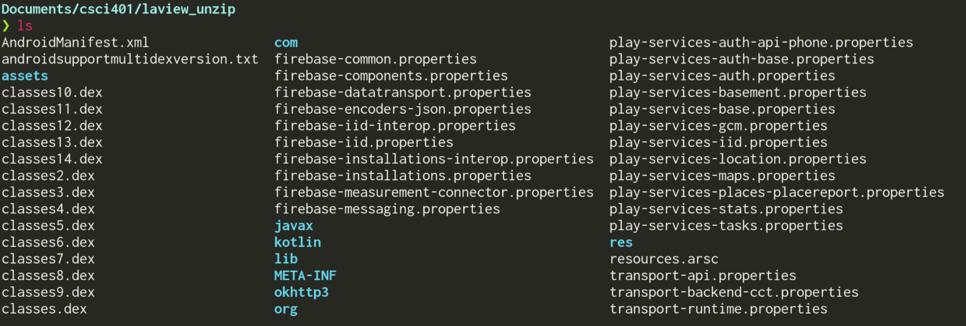

From this directory structure we could tell:

* User interface is made with Flutter
* Control logic done with Kotlin
* Two sets of libraries for ARM32 and ARM64
* Uses some pretty standard libraries: libav, LLVM libc++, etc.
* libTuya

**Disassembling Tuya Libraries**

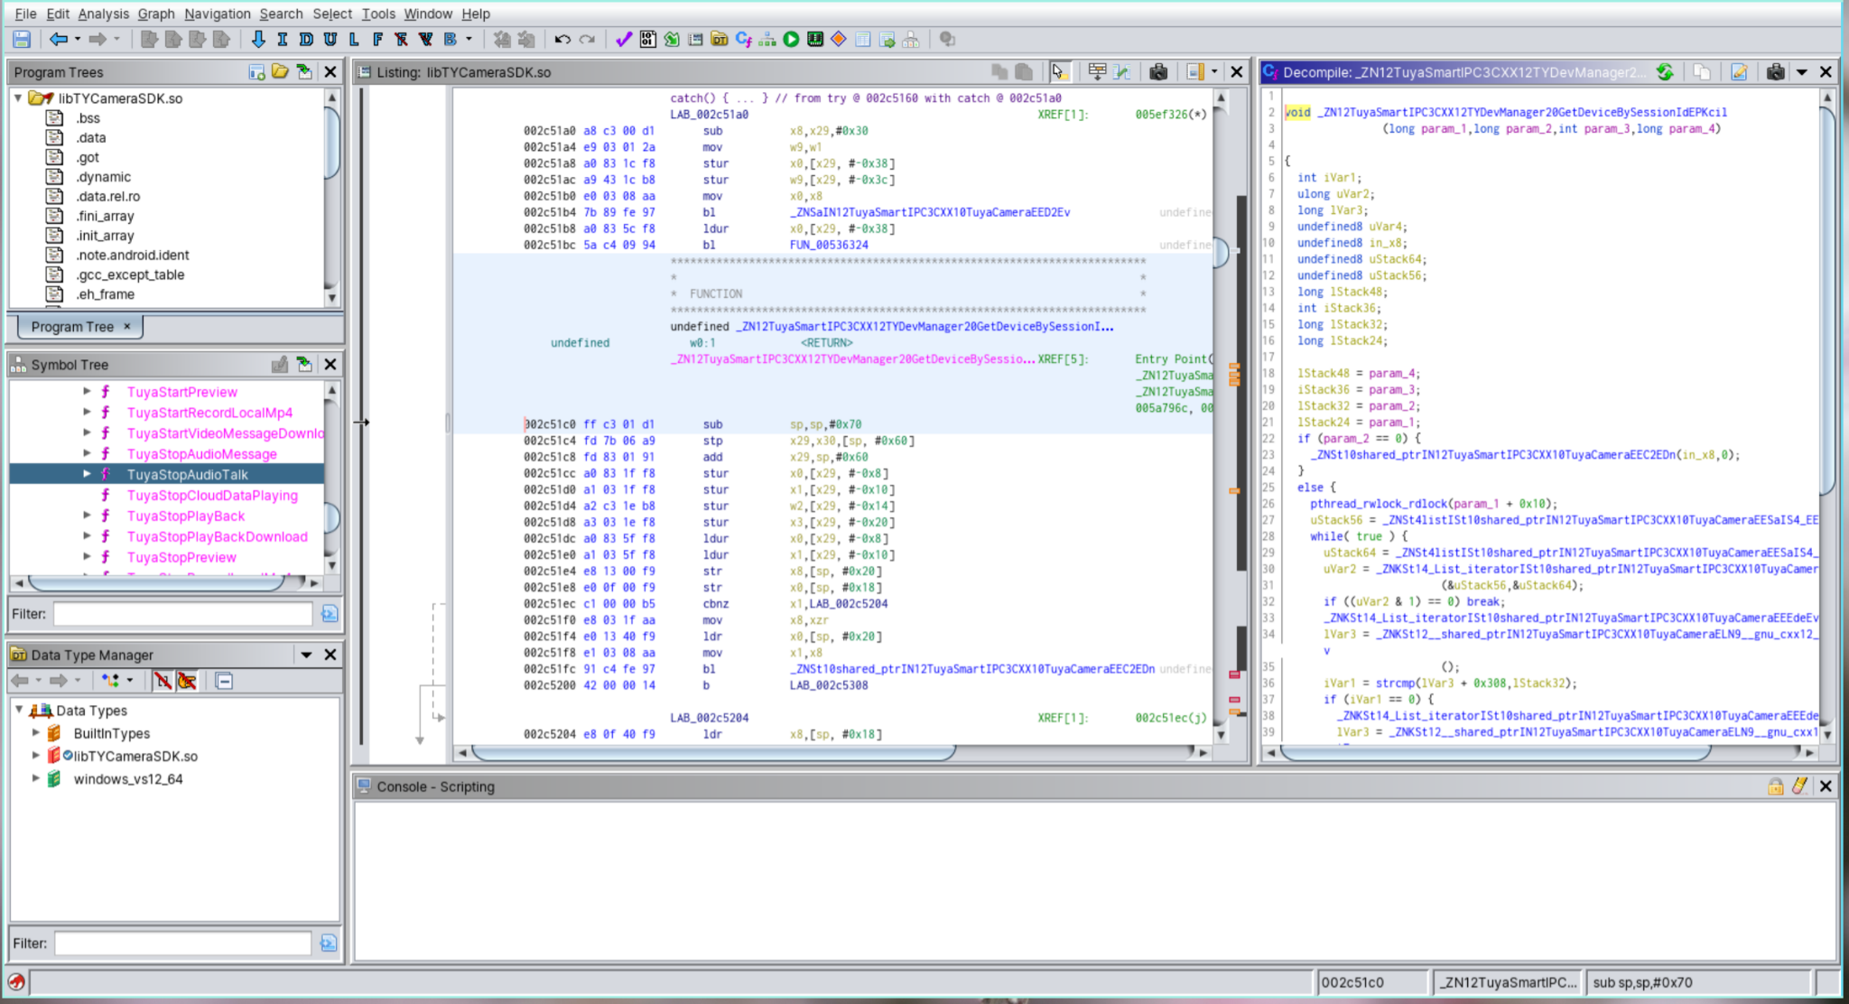

All functions here make a HTTP request through “Tuya cloud,” very suspect

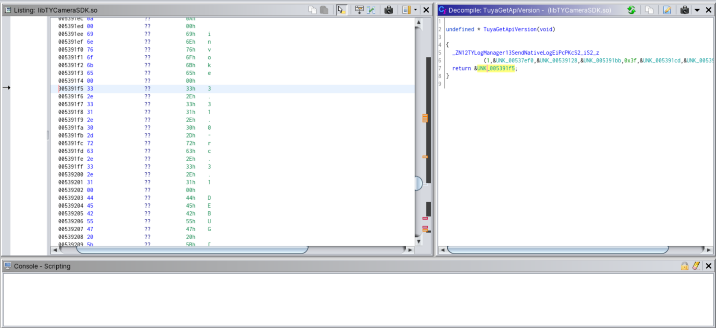

Tuya API version at 3.31.2 - possible exploits?

**Tuya**

* This is a IOT development platform (https://www.tuya.com/)
* Allows you to buy “off the shelf software” for IOT
* Seems like La-View Camera uses this platform
* Perhaps, we can find an exploit for Tuya’s technology platform and it will carry over to the La-View camera
* Additionally, we could attempt to find out what versions of libraries they are using and see if there are any known exploits for those versions of the libraries (which has presumable been patched in more recent editions)

**Deliverable 6:**

**Introduction:**

For this deliverable, we first used wireshark to identify the data that the camera sends out and the data it receives. This also helped us identify the different IP addresses the camera was sending data to and the camera’s own IP address. We then used nmap intense to scan the different ports on the camera and identify which of these are open and which of these are closed. This will help us focus on those ports on the camera which are open and thereby vulnerable to attack.

**Network connection method for camera:**

We used a hotspot to connect to the camera with the app. The camera scans a QR code which allows it to connect to the network. The following picture shows the decoded QR code, which contains a simple JSON with an unencrypted password.

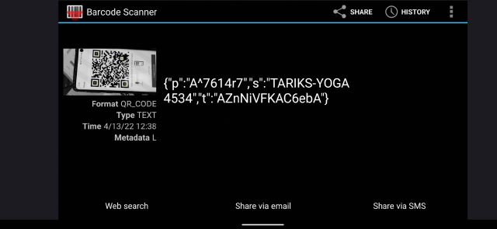

**Nmap Intense + UDP scan output:**

* Key takeaways are that the device is using Linux 2.6.32 - 3.10, an extremely old and vulnerable version
* We can use this information to find vulnerabilities in these old versions of linux.
* One of the UDP ports it found was a “NetworkVideoTransmitter” port

Raw output:

vikramkher@Vikrams-MBP ~ % sudo nmap -sS -sU -T4 -A -v 192.168.137.227

Starting Nmap 7.92 ( https://nmap.org ) at 2022-04-13 12:57 PDT

NSE: Loaded 155 scripts for scanning.

NSE: Script Pre-scanning.

Initiating NSE at 12:57

Completed NSE at 12:57, 0.00s elapsed

Initiating NSE at 12:57

Completed NSE at 12:57, 0.00s elapsed

Initiating NSE at 12:57

Completed NSE at 12:57, 0.00s elapsed

Initiating ARP Ping Scan at 12:57

Scanning 192.168.137.227 [1 port]

Completed ARP Ping Scan at 12:57, 0.10s elapsed (1 total hosts)

Initiating Parallel DNS resolution of 1 host. at 12:57

Completed Parallel DNS resolution of 1 host. at 12:57, 0.04s elapsed

Initiating SYN Stealth Scan at 12:57

Scanning 101207387.mshome.net (192.168.137.227) [1000 ports]

Discovered open port 6668/tcp on 192.168.137.227

Completed SYN Stealth Scan at 12:57, 0.83s elapsed (1000 total ports)

Initiating UDP Scan at 12:57

Scanning 101207387.mshome.net (192.168.137.227) [1000 ports]

Increasing send delay for 192.168.137.227 from 0 to 50 due to 11 out of 19 dropped probes since last increase.

Increasing send delay for 192.168.137.227 from 50 to 100 due to max_successful_tryno increase to 5

Increasing send delay for 192.168.137.227 from 100 to 200 due to max_successful_tryno increase to 6

Warning: 192.168.137.227 giving up on port because retransmission cap hit (6).

UDP Scan Timing: About 10.73% done; ETC: 13:02 (0:04:18 remaining)

Increasing send delay for 192.168.137.227 from 200 to 400 due to 11 out of 11 dropped probes since last increase.

Increasing send delay for 192.168.137.227 from 400 to 800 due to 11 out of 12 dropped probes since last increase.

UDP Scan Timing: About 13.86% done; ETC: 13:04 (0:06:19 remaining)

UDP Scan Timing: About 16.83% done; ETC: 13:06 (0:07:30 remaining)

UDP Scan Timing: About 20.09% done; ETC: 13:07 (0:08:01 remaining)

UDP Scan Timing: About 25.11% done; ETC: 13:09 (0:08:33 remaining)

UDP Scan Timing: About 39.09% done; ETC: 13:10 (0:07:58 remaining)

UDP Scan Timing: About 48.83% done; ETC: 13:11 (0:07:18 remaining)

UDP Scan Timing: About 54.87% done; ETC: 13:12 (0:06:33 remaining)

UDP Scan Timing: About 60.39% done; ETC: 13:12 (0:05:49 remaining)

UDP Scan Timing: About 65.94% done; ETC: 13:12 (0:05:04 remaining)

UDP Scan Timing: About 71.66% done; ETC: 13:12 (0:04:17 remaining)

UDP Scan Timing: About 77.09% done; ETC: 13:12 (0:03:31 remaining)

UDP Scan Timing: About 82.27% done; ETC: 13:13 (0:02:44 remaining)

UDP Scan Timing: About 87.36% done; ETC: 13:13 (0:01:57 remaining)

UDP Scan Timing: About 92.47% done; ETC: 13:13 (0:01:10 remaining)

Discovered open port 3702/udp on 192.168.137.227

Discovered open port 3703/udp on 192.168.137.227

Completed UDP Scan at 13:13, 978.96s elapsed (1000 total ports)

Initiating Service scan at 13:13

Scanning 54 services on 101207387.mshome.net (192.168.137.227)

Service scan Timing: About 5.56% done; ETC: 13:29 (0:14:27 remaining)

Service scan Timing: About 12.96% done; ETC: 13:24 (0:09:04 remaining)

Service scan Timing: About 61.11% done; ETC: 13:17 (0:01:14 remaining)

Service scan Timing: About 74.07% done; ETC: 13:17 (0:00:56 remaining)

Completed Service scan at 13:16, 175.20s elapsed (54 services on 1 host)

Initiating OS detection (try #1) against 101207387.mshome.net (192.168.137.227)

NSE: Script scanning 192.168.137.227.

Initiating NSE at 13:16

Completed NSE at 13:18, 121.45s elapsed

Initiating NSE at 13:18

Completed NSE at 13:18, 1.03s elapsed

Initiating NSE at 13:18

Completed NSE at 13:18, 0.01s elapsed

Nmap scan report for 101207387.mshome.net (192.168.137.227)

Host is up (0.015s latency).

Not shown: 999 closed tcp ports (reset), 947 closed udp ports (port-unreach), 51 open|filtered udp ports (no-response)

PORT STATE SERVICE VERSION

6668/tcp open irc?

|_irc-info: Unable to open connection

| fingerprint-strings:

| afp:

| MjB^Z

| .;H%

| MjB^Z

| .;H%

| MjB^Z

| giop:

| 4@nQ

|_ ?vin%x

3702/udp open tcpwrapped

| wsdd-discover:

| Devices

| Message id: 10120738-7dd2-21b2-a205-4A1649881014

| Address: http://192.168.137.227:8000/onvif/device_service

|_ Type: n:NetworkVideoTransmitter tds:Device

3703/udp open tcpwrapped

1 service unrecognized despite returning data. If you know the service/version, please submit the following fingerprint at https://nmap.org/cgi-bin/submit.cgi?new-service :

SF-Port6668-TCP:V=7.92%I=7%D=4/13%Time=62572FA7%P=x86_64-apple-darwin17.7.

SF:0%r(afp,27D,"\0\0U\xaa\0\0\0\0\0\0\0\x08\0\0\0K\0\0\0\x003\.3\0\0\0\0\0

SF:\0\xa0A\0\0\0\x01\xb8\xc3G\xdac\nS\xf5\xba\xbd2\x90\xb3\xf7R\rc\xdcK\xf

SF:3\x82rCg\xc0\x20\x0b\xb93\xcb\xa5\xcfM\|6\xb9U\xd0C\xbf\xfa\xeb:\r\x914

SF:\xd8\xdc\x1c\xfc\.\xcc\0\0\xaaU\0\0U\xaa\0\0\0\0\0\0\0\x08\0\0\0K\0\0\0

SF:\x003\.3\0\0\0\0\0\0\xa0B\0\0\0\x01\xb8\xc3G\xdac\nS\xf5\xba\xbd2\x90\x

SF:b3\xf7R\rc\xdcK\xf3\x82rCg\xc0\x20\x0b\xb93\xcb\xa5\xcfM\|6\xb9U\xd0C\x

SF:bf\xfa\xeb:\r\x914\xd8\xdc\x9f\x95\xfe\x0f\0\0\xaaU\0\0U\xaa\0\0\0\0\0\

SF:0\0\x08\0\0\0K\0\0\0\x003\.3\0\0\0\0\0\0\xa0C\0\0\0\x01\x08\x87\xcd\xa1

SF:\x9e\x83\r\xc3x\xf7a\x17>\xdeMjB\^Z\xfcQ\xa9\xc2s\x01t\xacBr{\x05\xf5\x

SF:ab\xb98\x92Yl\xfa\.6\xb7\.;H%\xda\xa9v\xa9\xea\xe5\0\0\xaaU\0\0U\xaa\0\

SF:0\0\0\0\0\0\x08\0\0\0K\0\0\0\x003\.3\0\0\0\0\0\0\xa0D\0\0\0\x01\x08\x87

SF:\xcd\xa1\x9e\x83\r\xc3x\xf7a\x17>\xdeMjB\^Z\xfcQ\xa9\xc2s\x01t\xacBr{\x

SF:05\xf5\xab\xb98\x92Yl\xfa\.6\xb7\.;H%\xda\xa9\xd5\xd3\xfdc\0\0\xaaU\0\0

SF:U\xaa\0\0\0\0\0\0\0\x08\0\0\0K\0\0\0\x003\.3\0\0\0\0\0\0\xa0E\0\0\0\x01

SF:\xb8\xc3G\xdac\nS\xf5\xba\xbd2\x90\xb3\xf7R\rc\xdcK\xf3\x82rCg\xc0\x20\

SF:x0b\xb93\xcb\xa5\xcf/\xef\x1dz\xbb\xcb\nH\xc8\x13\xa3\xaa\xc1<\xadj\xda

SF:\xef/D\0\0\xaaU\0\0U\xaa\0\0\0\0\0\0\0\x08\0\0\0K\0\0\0\x003\.3\0\0\0\0

SF:\0\0\xa0F\0\0\0\x01\xb8\xc3G\xdac\nS\xf5\xba\xbd2\x90\xb3\xf7R\rc\xdcK\

SF:xf3\x82rCg\xc0\x20\x0b\xb93\xcb\xa5\xcf/\xef\x1dz\xbb\xcb\nH\xc8\x13\xa

SF:3\xaa\xc1<\xadjY\x86\xff\x87\0\0\xaaU\0\0U\xaa\0\0\0\0\0\0\0\x08\0\0\0K

SF:\0\0\0\x003\.3\0\0\0\0\0\0\xa0H\0\0\0\x01\x08\x87\xcd\xa1\x9e\x83\r\xc3

SF:x\xf7a\x17>\xdeMjB\^Z\xfcQ\xa9\xc2s\x01t\xacBr{\x05\xf5\x12\xa2\xe5\x7f

SF:\xd4\.:\xef\x8d\xb3\x10\xd8\xbf3h`\x1b\x11E\x8f\0\0\xaaU")%r(giop,27D,"

SF:\0\0U\xaa\0\0\0\0\0\0\0\x08\0\0\0K\0\0\0\x003\.3\0\0\0\0\0\0\xa0J\0\0\0

SF:\x01\x84J\x93#N\xef\xf97u5\xdaU\xab\xe9\xc2\xc3<e\xa2Y6\xaen\xd4\x84\xe

SF:2\xa2\x92\xc9\x92\xda\xa5\x9a&\xc5\r\xd4\xd5\xe2\xb2K\xe4\xb2I\xd3\x98Y

SF:\nz\x1c\x9a\x07\0\0\xaaU\0\0U\xaa\0\0\0\0\0\0\0\x08\0\0\0K\0\0\0\x003\.

SF:3\0\0\0\0\0\0\xa0K\0\0\0\x01\x08\x87\xcd\xa1\x9e\x83\r\xc3x\xf7a\x17>\x

SF:deMjk\xe1\]\x89\xa0\xeb\xf1\xe2\xfe\x99\xccI\x98P\x15\xf8\xcf\x07\xb7\x

SF:82}a%\x1c\x8a\x1dj\xd1\x92\xc4\)\xe8\x85!\xdc\xce\0\0\xaaU\0\0U\xaa\0\0

SF:\0\0\0\0\0\x08\0\0\0K\0\0\0\x003\.3\0\0\0\0\0\0\xa0L\0\0\0\x01\x08\x87\

SF:xcd\xa1\x9e\x83\r\xc3x\xf7a\x17>\xdeMjk\xe1\]\x89\xa0\xeb\xf1\xe2\xfe\x

SF:99\xccI\x98P\x15\xf8\xcf\x07\xb7\x82}a%\x1c\x8a\x1dj\xd1\x92\xc4\)\xe8&

SF:\[\xcbH\0\0\xaaU\0\0U\xaa\0\0\0\0\0\0\0\x08\0\0\0K\0\0\0\x003\.3\0\0\0\

SF:0\0\0\xa0N\0\0\0\x01\x84J\x93#N\xef\xf97u5\xdaU\xab\xe9\xc2\xc3<e\xa2Y6

SF:\xaen\xd4\x84\xe2\xa2\x92\xc9\x92\xda\xa5\xb9\x9a\xc9E\xc8\xf2V\x8b\xe5

SF:\xb2\x05Bb\x03\xd54@nQ\xa6\0\0\xaaU\0\0U\xaa\0\0\0\0\0\0\0\x08\0\0\0K\0

SF:\0\0\x003\.3\0\0\0\0\0\0\xa0O\0\0\0\x01\x84J\x93#N\xef\xf97u5\xdaU\xab\

SF:xe9\xc2\xc3<e\xa2Y6\xaen\xd4\x84\xe2\xa2\x92\xc9\x92\xda\xa5\xb9\x9a\xc

SF:9E\xc8\xf2V\x8b\xe5\xb2\x05Bb\x03\xd54>\xb6\xe1\xe7\0\0\xaaU\0\0U\xaa\0

SF:\0\0\0\0\0\0\x08\0\0\0K\0\0\0\x003\.3\0\0\0\0\0\0\xa0P\0\0\0\x01\x08\x8

SF:7\xcd\xa1\x9e\x83\r\xc3x\xf7a\x17>\xdeMjk\xe1\]\x89\xa0\xeb\xf1\xe2\xfe

SF:\x99\xccI\x98P\x15\xf8\0\)\xb4f\xa0\xa8\xb4\x87\x20\xfaxm\x94\?vin%x\x1

SF:3\0\0\xaaU\0\0U\xaa\0\0\0\0\0\0\0\x08\0\0\0K\0\0\0\x003\.3\0\0\0\0\0\0\

SF:xa0Q\0\0\0\x01\x08\x87\xcd\xa1\x9e\x83\r\xc3x\xf7a\x17>\xdeMjk\xe1\]\x8

SF:9\xa0\xeb\xf1\xe2\xfe\x99\xccI\x98P\x15\xf8\0\)\xb4f\xa0\xa8\xb4\x87\x2

SF:0\xfaxm\x94\?vi\x10\xfd\xc8R\0\0\xaaU");

MAC Address: 84:7A:B6:23:C0:EA (AltoBeam (China))

Device type: general purpose

Running: Linux 2.6.X|3.X

OS CPE: cpe:/o:linux:linux_kernel:2.6 cpe:/o:linux:linux_kernel:3

OS details: Linux 2.6.32 - 3.10

Uptime guess: 0.020 days (since Wed Apr 13 12:50:19 2022)

Network Distance: 1 hop

TCP Sequence Prediction: Difficulty=263 (Good luck!)

IP ID Sequence Generation: All zeros

TRACEROUTE

HOP RTT ADDRESS

1 15.45 ms 101207387.mshome.net (192.168.137.227)

NSE: Script Post-scanning.

Initiating NSE at 13:18

Completed NSE at 13:18, 0.00s elapsed

Initiating NSE at 13:18

Completed NSE at 13:18, 0.00s elapsed

Initiating NSE at 13:18

Completed NSE at 13:18, 0.00s elapsed

Read data files from: /usr/local/bin/../share/nmap

OS and Service detection performed. Please report any incorrect results at https://nmap.org/submit/ .

Nmap done: 1 IP address (1 host up) scanned in 1280.82 seconds

Raw packets sent: 2779 (128.914KB) | Rcvd: 2086 (139.550KB)

We attempted to connect to an open TCP port on :6668, but a netcat connection did not provide any prompts.

**Wireshark**

We did a complete packet capture of network traffic during our testing, which can be found at:

<https://drive.google.com/file/d/1E_87v9dGABbrcbCqVoNnNYySncdzL88p/view?usp=sharing>

We have been analyzing this trace as well, with a few key takeaways:

* Camera is controlled by an encrypted MQTT connection to an AWS server
* No data is transmitted to the camera locally

**Nessus Vulnerability Scanner**

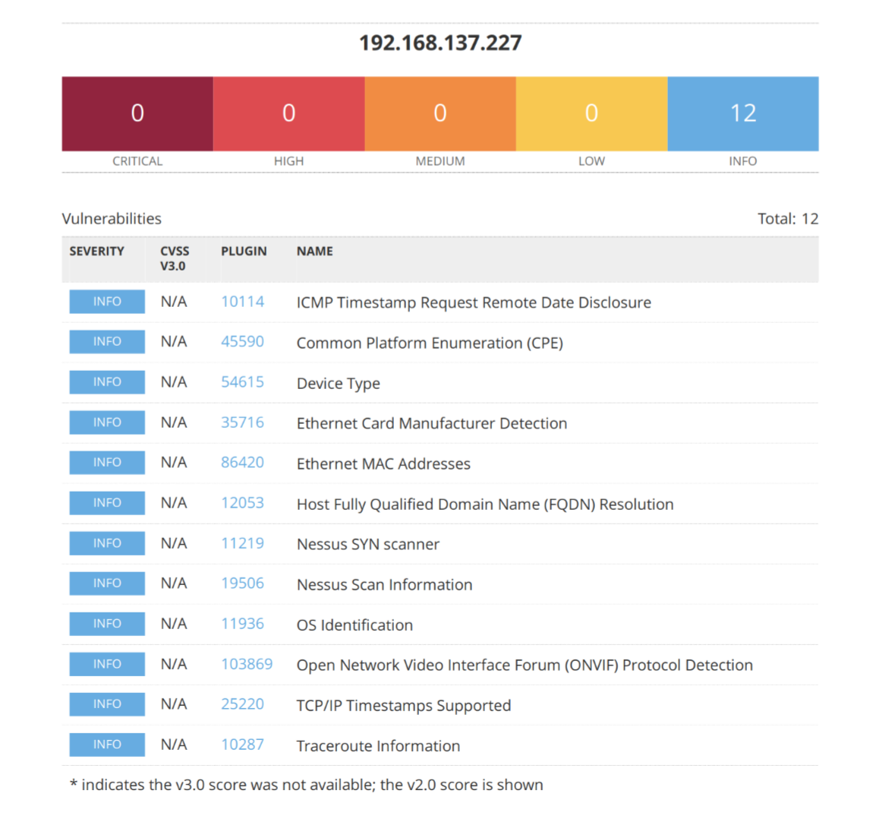

#### **OS Identification**

Remote operating system : Linux Kernel 2.6

Confidence level : 56

Method : MLSinFP

#### **Nessus SYN scanner**

Port 6668/tcp was found to be open

#### **Open Network Video Interface Forum (ONVIF) Protocol Detection**

The ONVIF service listening on UDP port 3702 advertises

the following information:

Endpoint: http://192.168.137.227:8000/onvif/device_service

Name: IPC_101207387